PROJECT REPORT FORMAT

**Building A BlogApp**

INTRODUCTION:-

The blog app is a web application that provides real-time blog posts. Based on products, Solutions, New technologies, New projects, and Management. The blog app is fully responsive. The blog is made using Java script, CSS, HTML,and Bootstraps. The central theme of the blog is to show new ideas and new innovations on one website.

Whether it’s personal or professional, a blog provides endless opportunities for a website’s traffic growth. Not to mention, the popularity of blogs hasn't diminished. In fact, the opposite is true: As Neal Shaffer, founder of the digital marketing consultancy PDCA Social says, [blogging isn’t dead](https://nealschaffer.com/is-blogging-dead/), “blogs are useful for a lot more than just sharing your thoughts. In fact, 60% of consumers will buy something after they’ve read a blog post.

LITERATURE SURVEY:-

Before you begin building the Blog App, ensure you have the following:

- A code editor (e.g., Visual Studio Code, Sublime Text, Atom)

- A web browser

- An internet connection

- Knowledge of HTML, CSS (or a CSS framework like Bootstrap), and JavaScript

By the end of this project, you will be able to:  
Create a user-friendly interface using HTML and CSS to display blog posts.

THEORITICAL ANALYSIS:-

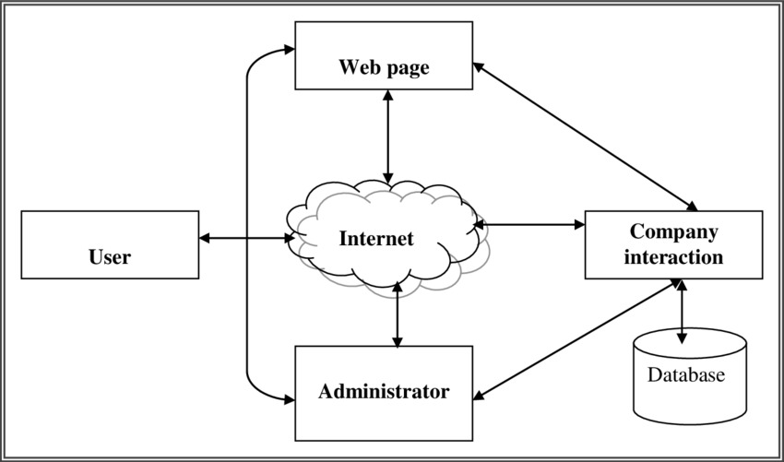

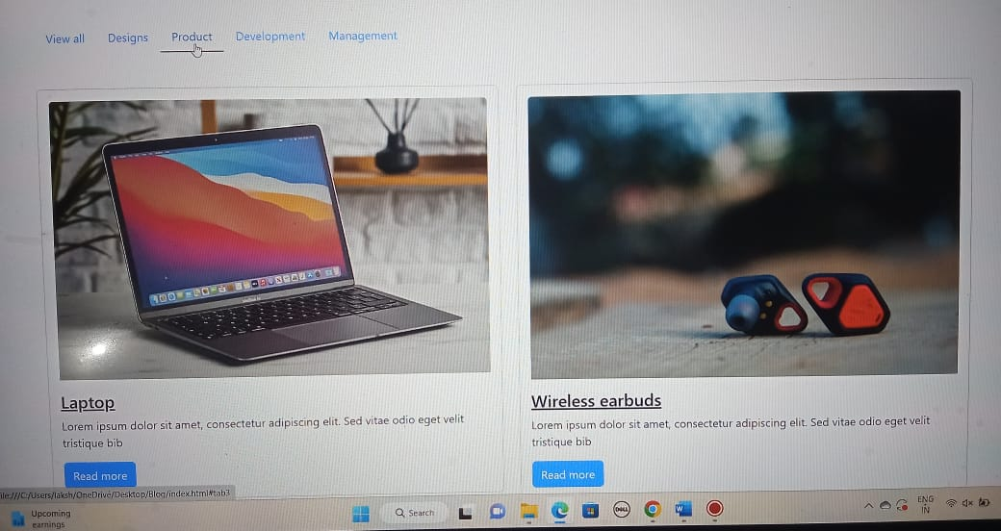

**RESULT:-**

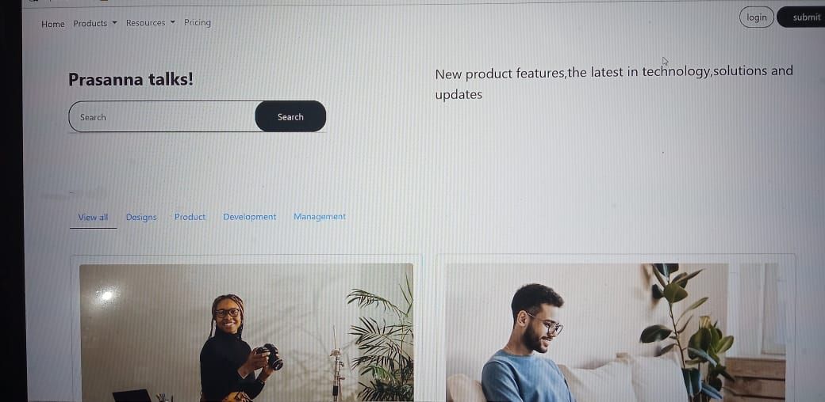

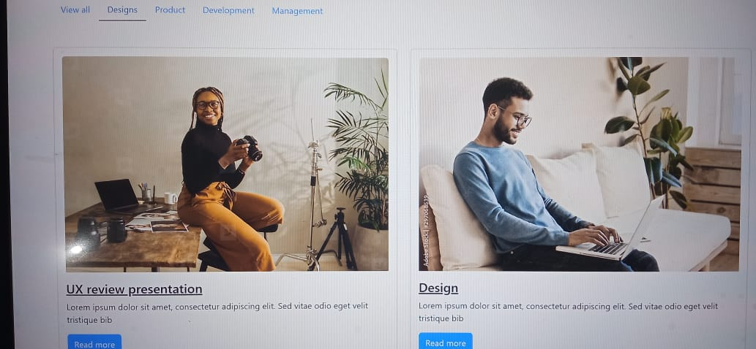

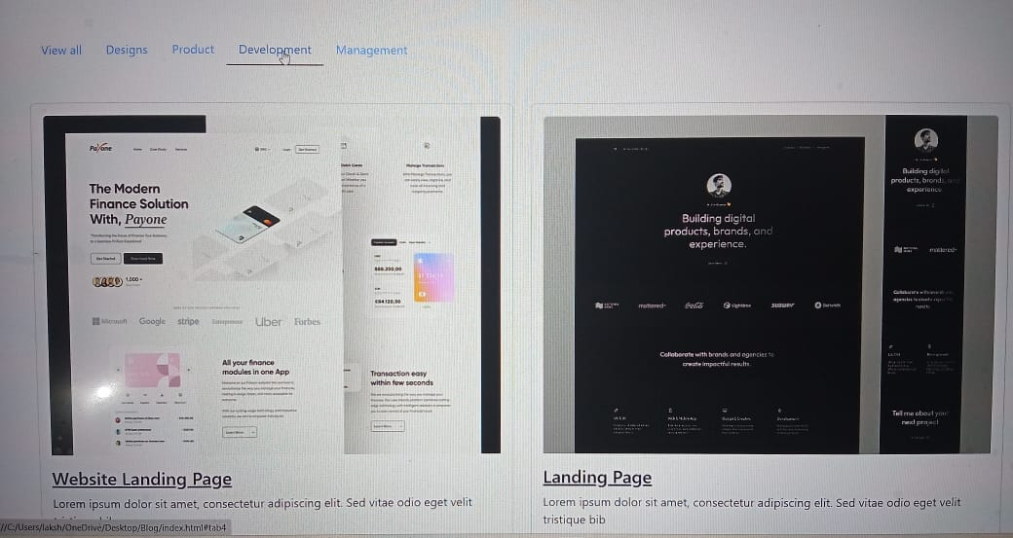



ADVANTAGES & DISADVANTAGES:-

Advantages of Blog

Blogs are a big source of information used by the majority for sharing and receiving information. The following are various advantages of the blog:

**1. SEO (Search Engine Optimization)**

This feature assures the presence of good content on blogs. As good content becomes a necessity to be recognized.

**2. Opportunities**

Anyone who aims to generate revenue can easily start by producing good content and attracting an audience. This becomes a constant stream of monetary benefit. This idea has helped develop business and stands out as a good opportunity for people.

**3. Personal Development**

There is a big possibility of personal development. By writing posts, one can get feedback from a large number of people from all around the world. This feedback is very useful for a person's self-development and career growth.

**4. Personal Influence and User Analysis**

Large companies spend a huge amount on consumer feedback, whereas here, we get that for free. By working on posts for blogs, if we create good content, a large number of visitors get attracted. This increases personal influence. Also, based on feedback or comments, one can analyze the type of visitors, their tastes, and personality. This helps in sorting content for posts.

**5. Freedom**

Blogs are based on personal commitment. One can work on posts on their will and availability. There is no time or work obligation. A person can work from anywhere and at any time. Also, there are no deadlines to meet, and no boss is there to order around.

**6. Flexibility**

This work does not require any dress code for work. This also facilitates working part-time and an ongoing full-time job. There is no boss or deadline. One can do this based on the availability of time. Also, the time allotment for working for blogs can be of an individual's choice.

Disadvantages of Blog

Blogs have many advantages that outweigh the disadvantages, but an idea of the same is very important. Followings are some of the disadvantages of the blog:

**1. Time Management**

The process of blog creation requires proper planning and thoughtfulness. This takes time. Proper planning about what to be included in the content, niche, and format to make it appreciable for large visitors. This process becomes more time-consuming for new bloggers as they lack experience, knowledge about the domain, and expertise. Most of the time, blogger spend their free hours working on their blog.

From the start to gaining significant recognition and establishing momentum in blogging, the process is long, tiring, and time-taking. Results are not so visible in the short run, but they do in the long run. It is more like demanding consistency with no guarantee of success. There is a very high chance of the person feeling like they are the only ones chasing their dreams and feeling alone. There are high chances of getting frustrated, discouraged, and developing a sense of uncertainty about success.

**3. Inconsistency and Lack of Self-Discipline**

There is always a problem of inconsistencies in posts which leads to less traffic on the website of the blog. Also, there is no boss or deadline in working on a blog which brings to the importance of self-discipline. Every deadline must be met to maintain consistency, and this huge responsibility lies on my shoulders.

**4. Technical Problems**

People using WordPress faces problem, which usually include the setup time and process. Initially, people are unfamiliar with blog settings, features, and services. Also, people are good with writeups and content but find the technicalities hard to handle.

**5. Marketing**

People have limited connections. Even if they share it on social media sites, it does not contribute significantly to driving enough traffic. Even if the content is good, the validation depends on how many visitors are interested in visiting again for new content. This is one of the most important aspects of the blog's growth.

**6. Social Validations**

People don't feel confident about being a blogger as this does not bring affirmation from people of the social groups around them. As an option for a full-time career, this may bring negative comments from immediate family and friends. This is also a very important aspect in determining the probability of success in the career.

APPLICATIONS:-

Whether you’ve seen stand-alone blogs or blogs as website sections, you’ve probably encountered[blog examples](https://www.wix.com/blog/blog-examples) all over the internet. Some of the most popular types of blogs in the [blogosphere](https://www.wix.com/encyclopedia/definition/blogosphere) include:

·        Food blogs

·        Travel blogs

·        Health and fitness blogs

·        Lifestyle blogs

·        Fashion and beauty blogs

·        Parenting blogs

·        Business blogs

·        Sports blogs

·        [Art blogs](https://www.wix.com/blog/best-art-blogs-to-inspire-you)

·

CONCLUSION:-

The Blog App is a web application that provides real-time information and updates of new technologies: products, and solutions to the users. The project's modular structure allows for easy-to-read the post. The project features additional UI and a responsive search bar and that card should show the details.



Blogging is getting more and more hype day by day. And **India is one of those countries from where amazing blogging talent is rising**.

In 2020, **according to a survey**, there was a total of 10,000 bloggers in India from which 5000 actively and regularly post content on their websites.

**Is it possible to make a living by blogging in India? Is Blogging a Lucrative Business?**

All of the questions above have a **yes** answer. But how does this happen? Everything about blogging in India will be explored in this post, as well as the **future of blogging**in the next decade.